**Program: Management information system for COVID-19**

Group: Xuanbang Liu, Zeyang Zhou

### Idea and Inspiration- Zeyang Zhou, Xuanbang Liu - DONE

1. COVID-19
2. MIS, storage and mgmt of data
3. We received emails from SU about the rapid increase of COVID-19 cases caused by on or off campus’s **gatherings** and **Clusters.**

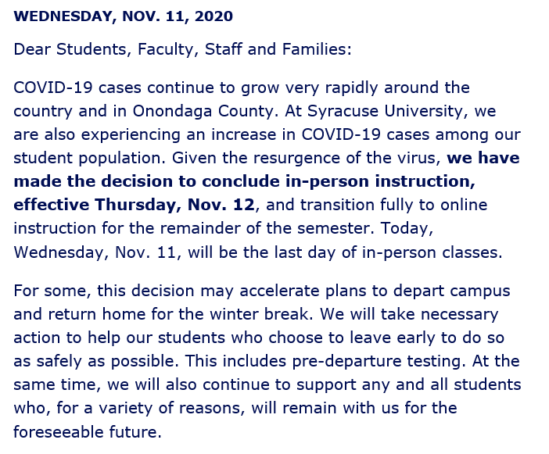

1. It also works with flus or other infectious diseases.

We divided our work into the front end and back end ,and finally we merged them together.

### Conceptual model and ER requirements

Student ER requirements and conceptual model - Zeyang Zhou - DONE

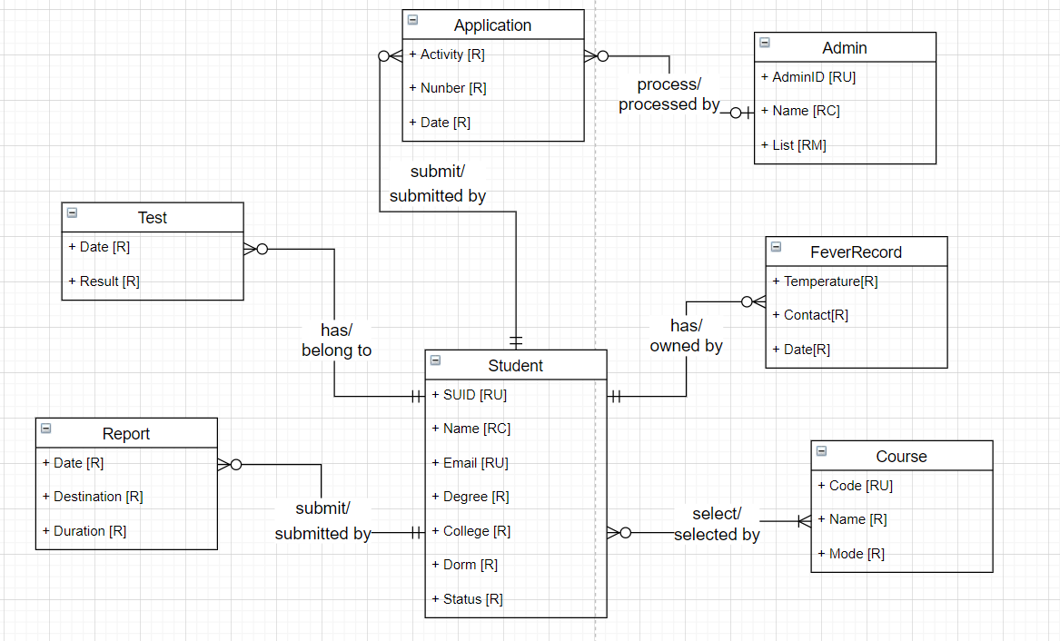

### ERD

Student ER diagrams - Zeyang Zhou - DONE

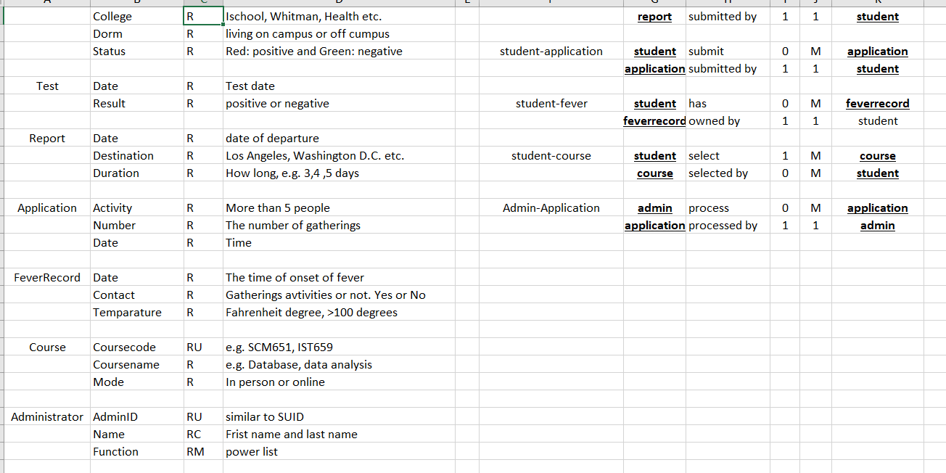

### Logic model

Student Logic model - Zeyang Zhou - DONE

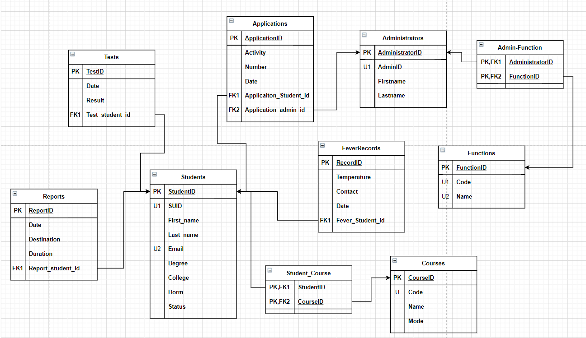

Brown- Zeyang Zhou; Red: Xuanbang Liu

### SQL up&down file and Sample data - DONE

### User stories - DONE

### External Data Model - DONE

12/8 11:59PM - DONE

12/9 8:00 PM - Zeyang: External Data Model- DONE; Xuanbang: powerapp- DONE

12/10 7:00AM - presentation- DONE

### Logical design of UI layout (doc) -12/10 9:00AM- DONE

### Powerapp - DONE

### Presentation (slide, video, video(powerapp)) - link 3, link 2- DONE

Slide: intro + outlining the problem, data model, then user stories, external model, and powerapps demo showing it works

12/10 11:40am - Logical design of UI layout (doc), link 3, link2 , slide, doc.

Due: 12/10 12:59pm

Link:

Presentation video link:

<https://video.syr.edu/media/t/1_70mtz8o5>

Powerapp video link:

<https://video.syr.edu/media/1_1xpm2p4d>

Reflection video link (Xuanbang Liu):

<https://video.syr.edu/media/1_e0oi8rhv>

Reflection video link (Zeyang Zhou):

<https://video.syr.edu/media/t/1_5v32l429>